LISA Voltage Divider and PMT Assembly Manual
(March 2010, updated March 27, 2010)

Chapter 1 Removing the Divider Circuit Boards from the PCB Frames

The actual circular circuit boards with the needed resistors and capacitors need to be removed from the frame. They are produced 12 to a frame. This involves cutting. A number of methods were explored and this chapter describes what seemed to work the best. Before starting the details…

DO NOT BEND THE BOARDS
DO NOT USE POWER TOOLS
DO NOT DAMAGE THE TRACES
DO NOT CLAMP THE BOARDS WHICH CAN CRACK THE COMPONENTS

First what did not work. Jim Vincent used a high speed Dremel tool with a carbide cut off wheel. This is not the preferred approach because:
- Eye protection is required since the cut off wheels frequently fracture and fly off.
- It is very easy to slip and run the wheel over the surface of the circuit damaging the traces.
- The carbide dust from the cut off wheel could lodge under or on the components and affect the values.

A variety of hobby/XActo tools were tried. One can buy a small “fine” narrow ~2” blade for your tool handle. One can get a finer blade (1” by 3”) that has a reinforced back. The first blade was way too coarse and hard to control. The other blades cut on the back stroke rather than down stroke making it harder to use. Also, these all went dull very quickly. The PCB material is not metal but is more abrasive than wood or plexiglass.

A coping saw was not bad but was a bit hard to control and there were times when the blade had to be attached to the frame while holding everything with three hands.

WHAT WORKED
The easiest was a standard 24 tooth/inch hacksaw blade (mine was made by Stanley). I would get one marked for “high speed” and/or metal. Spend an extra buck rather than getting the cheapest. Don’t use a hacksaw frame. Just hold it (what I did), wrap some tape around it if you find the teeth too sharp, or one can get a handle thing where the blade sticks out past the end (it was okay for me but I preferred just holding it.) Remember that you can hold a blade upside down so that it cuts on the up-stroke. You should hold this so that it cuts when you push down. My blade had arrows showing the cutting direction.

SOME VOCABULARY

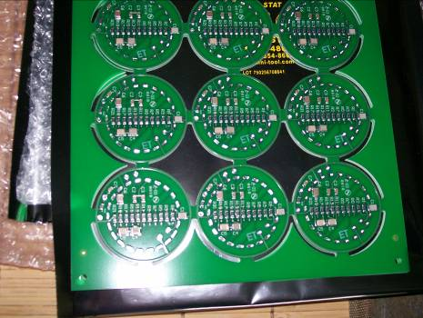
round trace
capacitor
Capacitor side of the board or bottom side. This will end up against the socket.

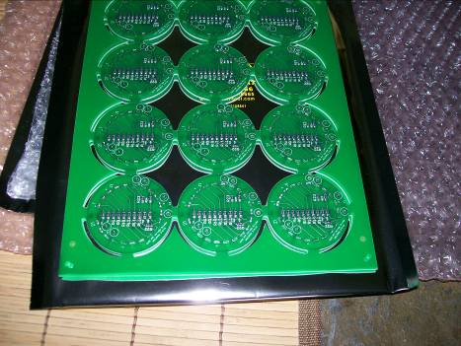
“Other” side of the board. This is also the top side as it will be the side that is away from the socket. Note no capacitors and “R22” is visible.

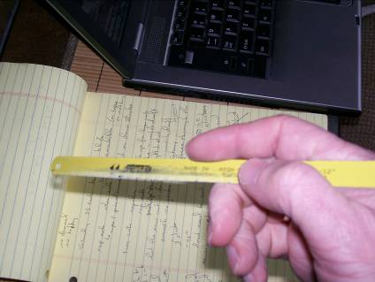
The “regular” hold which is the same way I hold a pencil with the blade above the thumb joint.


A different regular hold. In this case the blade is under the palm.
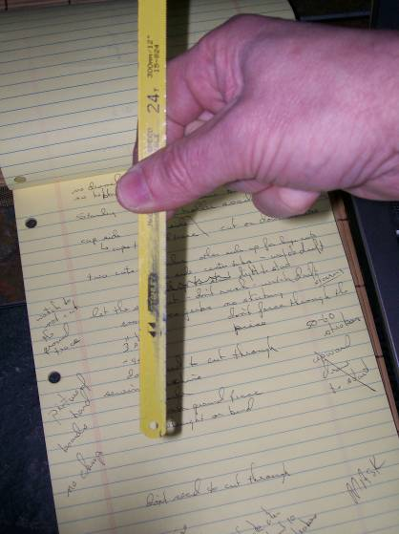
The “sewing machine” hold.

GENERAL CONSIDERATIONS

- Pay attention. The saw can drift into the ground trace if you are not careful. Blow the dust off as you go and LOOK at how the cut is progressing.
- If you have respiratory issues you may want a mask. There is not a lot of dust but PCB can be an irritant.
- You don’t need to cut all the way through. Sometimes the last little bit will be stubborn and catch in the saw. Just quit because that little bit can be broken when all the tabs are cut or weakened.
- Do not clamp the board. Just hold securely by hand.
- You can practice the cuts in the scrap around the outside before tackling the round parts.
- Hold so the blade cuts on the down stroke.

THE EASY CUTS: LARGE IN FROM THE SIDES

I needed this hold to divide up the boards so everyone got 33. Others may use it to avoid the sewing machine cuts which are annoying and harder. Pick the location of the cut and be sure to hold the board with the “other” side up. This is so that when the cut breaks through you do not nick the ground trace. USE LIGHT, LIGHT, LIGHT PRESSURE. Let the saw do the work. It will be 60 or more strokes to cut in from the edge. A light longer stroke (2-3”) is better than a frenetic short stroke. The blade should make a 30 to 45 degree angle with the board while cutting. If the blade binds while cutting your are either using too much pressure or you have the blade crocked in the slot. When it is correct there is almost no effort and no jerking. If the saw gets stuck and jerky for the last little bit, just quit and break it when all the cuts are done.

THE OTHER EASY CUT: THE TABS BETWEEN THE CIRCLES

This is the same as above but hold the board with capacitor side up. You need to be sure the saw does not drift into the ground trace. Blow the dust off and pay attention. Now if the blade is drifting into the trace you will need to steer the blade away. Back the blade out of the slot and start cutting again (light pressure) with just a slight twist of the blade so that it makes the slot wider and works away from the trace. The best thing is to start straight and finish straight.

THE HARD CUT: TABS CONNECTING TO THE OUTSIDE FRAME

In general again LIGHTER is better here. This cut is done in two parts, one from each side of the tab. The cut is done more like a sewing machine instead of like regular sawing. Use the sewing machine grip. When done the extra tab left on the circuit will be a little V. This cut should be done with the capacitor side up to be sure you do not go into the ground trace. One thing that can be a issue here is that if the blade is not really straight from the very start it will twist as you cut and bind.

REMOVING THE TABS

This is done with a small sharp, NEW, metal file. Don’t use an old file because it will not be sharp, you will slip as you press hard, and hit the board. 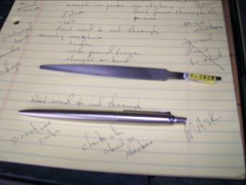

The filing off of the tabs is done in two step. First, file sidewise, up and down across the edge of the board (the file should point parallel to the board’s normal vector). Almost all the material should be removed this way. Be sure not to file into the ground trace so be sure to do this with the capacitor side up. The reason for filing in this orientation is that it minimizes the likelihood of slipping off the side of the circuit and causing damage. IF you feel the need to finish the trimming by rounding the side, hold the board in a way so that the file rests on your index finger as you file around the edge. You must positively work to keep the board centered on the file. One slip of the file across the surface and the board can be ruined. These pictures are not that good but they try to show (on a corner) what I mean.
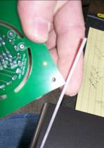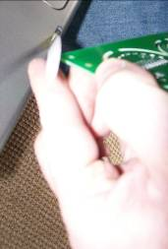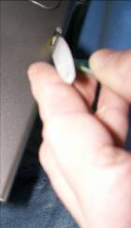

Begin March 27 update.

This hand filling is the safest but it will take some time since some of the tab remnants are large. I did successfully use a dremel high speed tool to remove the bulk of the material before finishing by hand. This does require a steady hand and if you slip the board can be easily damaged.

WEAR EYE PROTECTION
WEAR A DUST MASK

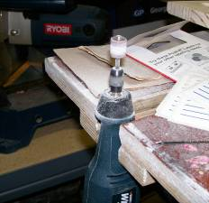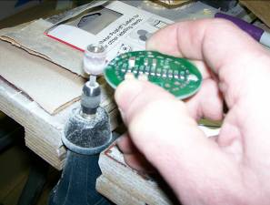

There are several key tricks that make this work better. The first is to use two hands unlike the picture (I needed a hand for the camera). Then clamp the tool and be sure you have a hand rest to provide the best control. Holding the piece against the tool without a “hand-rest” leads to bad results. The tool was set to a medium speed. If set too slow I had to press too hard and lost control. If set too high it was like a hot knife through butter. The actual abrasive is a fine, large-size dremel grinder. Is looks like a little tube of sandpaper (don’t get the smallest diameter). It is not a carbide or ceramic or stone; it is brown sand paper (mine was a pack with a few but one was enough). It also worked better to move the part against the direction of rotation. This seemed to give better control. My tool rotates counter-clockwise so I passed the PCB to the left. Hold the part with the capacitors up and WATCH THE GROUND TRACE. It is better to stop a little short and finish by hand than to grind through the trace.

End March 27 update

Chapter 2 Assembling the Voltage Divider

Section 1 Attaching the socket and jumper wires.
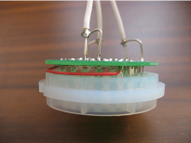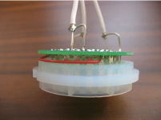

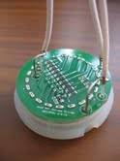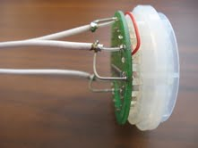
These are pictures of the assembly as done by Jim Vincent at the NSCL. The process below was modified to simplify the assembly. For example, the Teflon white coax is very stiff. You will see that we have used black RG174 since it is easier to flex. The red jumper wire was replaced with black Teflon coated 20AWB stranded wire and moved to the top of the PCB so that tabs are only soldered once and the jumper doesn’t fall out. The final big change to watch for is that we do not use coax for the HV connection.

Before starting any soldering, test fit the boards in the aluminum tubes to make sure that you have completely removed the excess tab material. Even so you may have to file more after assembly because of misalignment when soldering.

First General Comments
- No flux on the PCB, flux the socket tabs if they do not readily take the solder. (picture of flux)
- When soldering remember…
  - Set the temp appropriately
  - Clean off the iron tip with a damp sponge frequently as in every time you pick up the iron. We have been using about 700 F degrees.
  - Put a small amount of solder on the tip before touching the work for good conductivity
  - To actually solder, touch the solder near the tip but not the actual tip. You are not using the iron to melt solder to fall on the joint, you are trying to get the two parts hot enough at the same time so that solder flows onto the parts.
  - Excess solder is always a bad thing
  - Don’t overheat, don’t make cold joints
  - INSPECT EVERY JOINT WITH A MAGNIFIER. Solder joints that look like “not this” are bad. They should look like “this”.
this

MAKE COAX WIRES

The first step is to make two coax wire assemblies. The steps must be followed carefully here. We describe the making of one wire but of course one may want to make all the needed wires by doing each step for all the wires (66 total) rather than making the wires one at a time.
NOT this
- Cut a 4” length of coax.
- Trim approximately 1cm of black insulation off each end to expose the ground braid. Roll the wire while pressing with a sharp blade. Do not press so hard that you cut the inner braid. Then slit to the end of the wire and remove the black jacket.
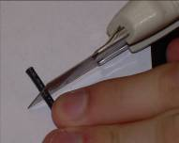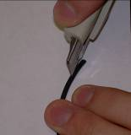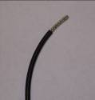

- Use a dental pick or some other sharp object to unbraid the braid. Work around the braid as you unbraid it rather than just pulling at one spot. Try to minimize the number of individual strands that you break off. When unbraided, pull ALL (look closely) the strands to one side and twist them back together.
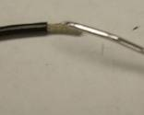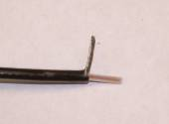
- Cut a length of single strand wire and strip off about 1” of insulation. Wind the wire around the black insulation, about 1 turn, and end with the wire along the twisted braid. Then wind the braid around the wire. Tin the braid and wire by applying some flux to the braid and solid wire.
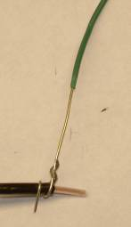

- Solder the wire but work at the end of braid away from the black insulation. Trim back the wire where is wraps around. Leave the solid wire (green in the picture) untrimmed and long until later. Solder this well but avoid excess solder since this will cause problems later. The connection must still be bendable.
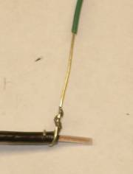
- Trim off about 1 to 2 mm of the inner Teflon insulation again by rolling a sharp blade over the end. Be careful not to let the inner strands get splayed out. 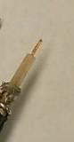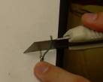
- Repeat for the other end. Again, it would be better to make a couple first to practice but then do step 1 to a group of wires, then step 2, etc.
- A quick test with an ohm meter to be sure that the center insulator was not damaged during soldering could be done here. Just look for “infinite” resistance (or OL on most meters) between the braid and center copper.

ATTACH THREE WIRES

Note that the anode wire and the dynode wire have a different distance between the center wire and ground connection on the board. Take this into account when fitting the wires to the board.

- Bend the ground braid/solid wire so that the wire will easily insert in either the anode or dynode set of holes on the board. The center conductor should go straight into its hole without any sideways stress. The ground wire may have to be bent over in the part where the wire and braid are soldered. Excess solder will make this difficult. NO LOOPING AROUND OR “S” BENDS IN THE GROUND LEG.
- Identify the proper holes on the board.
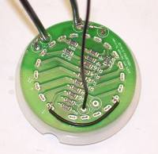
Dynode center
Dynode ground
Ignore this wire, comes later
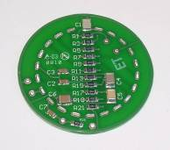
Not used
High voltage (not coax)
Anode center

Dynode ground

Dynode center

Anode ground
- Insert one of the coax wires and suspend the board so you can solder the center conductor and ground. YOU SHOULD BE LOOKING AT THE CAPACITORS AND LITTLE BIT OF CONDUCTOR. Don’t get them backwards because it is a mess to repair this mistake.
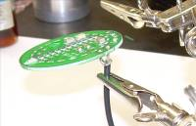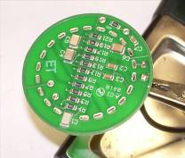
- Cut a 4” length of black stranded wire. Trim 1-2 mm of insulation from both ends. Solder into the HV (not ground) pad on the capacitor side of the board.
- Inspect with a magnifier and trim wire that projects through on the capacitor side.
- Picture of finished step. Note capacitors are on the back side and see the length of ground wire that will be trimmed to fit later.
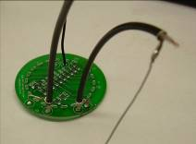

ATTACH THE BOARD TO THE SOCKET

You will notice that there a gap in the tab pattern on the board and a corresponding gap on the socket. Start by inserting the tabs at the gap. You will need a dental pick or tool like the following.
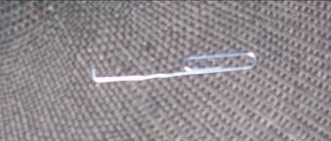
Use the hook to gently push and pull the tabs until they go in the slots. You will have to work both side toward the tabs opposite the gap. DO NOT BEND THE TABS OVER WITH EXCESS PRESSURE. When you find the last misaligned tab the board will push down onto the socket. I recommend doing a group of these rather than doing just one and moving on.

ADDING THE JUMPER WIRES

A careful look at the resistor or top side will show that there are two small A and two small B by some of the tabs. Two jumper wires must be added connecting the A tabs and the B tabs. The A wire is about 1 5/8” (before stripping) and the B wire should be 1 ¾”. The A wire is routed around the outside of the tab ring while the B wire will stand above the board.

I found that the best success is had by keeping the stripped end very short. Prebend the ends of the A wire and give it a curve so that it lays in the correct orientation without being held.

Insert the A wire and lift up on the board (don’t pull it off on the other side) so that the wire is trapped. Solder this in so that the board pad, socket tab, and wire are all soldered together. Do not overheat. Use good soldering technique here.

For the B wire, it helped to tin the end of the wire, insert it into the holes in the tabs, lift up on the board to capture the wire, solder it in (wire, tab, and board pad) with it laying flat, and then bend it up to stand above the board.

If you stripped too much insulation to begin with, trim excess length projecting through the tab with a small diagonal cutter.

INSPECT WITH A MAGNIFIER.
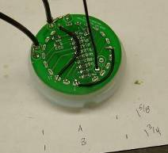

FINISH THE TABS

Finally, solder the remainder of the tabs (remember to touch solder to the tab and pad slightly to the side of the soldering iron tip) to the pads on the board and INSPECT (possibly you might want to have someone else inspect to insure quality).
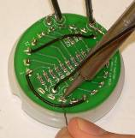

TEST FIT.

Test fit this assembly into one of the aluminum tubes. If too tight, carefully file the region on the board that is making the fit overly tight. The edge of the board can touch the inside of the tube but should not overly stress the socket-board connections when assembled. Besides just fitting into the tube, the assembly should be such that the socket/circuit/tube assembly will ultimately mate with the mu-metal shields. Some of the shields are tighter than others and if the circuit board causes the socket to be off center in the tube (there is a little leeway) then there will be difficulty later. Make sure the socket does not project past the edge of the aluminum tube. A small straight edge held against the side of the tube is useful for this. If it is projecting outside then file the circuit board a bit more.

PUT THE CONNECTORS IN THE BASE PLATE

The connectors are installed so that the solder cups are on the same side as the locating roll pins. Notice that there is an A and a D stamped in the surface. The HV connector goes in the unlabeled hole. The grounding lugs should be bent up BEFORE tightening the nut down. If you tighten first, it is very hard to get under them to bend them up. The nuts should be snugged up with a ½” open end wrench. Because the holes are D-shaped this does not have to be super tight; just tight.

Add some type of serial number (H01) to the base plate with a sharpie.
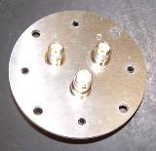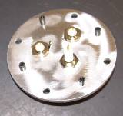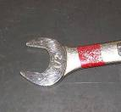

ATTACHING THE BASE PLATE

- Insert the socket and board into an Al tube. The socket goes in the end of the tube with a small relief machined on the inside. Use a little tape around the outside to hold the socket in place.
- Tin all the connector solder cups and flux and tin the two ground lugs (do not put so much solder on the lug that the hole fills in).
- Tin the HV wire and the two center conductors of the coax cable.
- Then hold the base plate as shown and solder the HV wire. Bend and trim the ground of the anode and dynode wires. The center should go straight in without sideways stress. The ground wire does NOT need to go through the hole and wrap around. If everything is good the ground wire will lie against the lug and you just solder it.
- BE SURE THE ANODE IS CONNECTED TO THE A CONNECTOR!
- IF you decide to do a quick test here, CAREFULLY attach a HV supply and see that the base draws 0.73mA (about) at 1500V. BE CAREFUL – EXPOSED HIGH VOLTAGE.
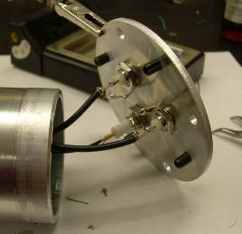

GLUING

Before starting this, look at the picture and see that you need a piece of pipe (aluminum, cardboard, whatever where the connectors will fit down inside. You also need a weight. A chunk of steel is shown.
- Remove any tape and pull out the socket.
- File about 6-8 small grooves on the part of the socket that goes up into the tube. Use a triangular file or a file with serrations on the edge. This will help the with adhesion to the Teflon base.
- Apply a thin layer of DAP 230 black caulk/adhesive (from Home Depot SKU070798182806). My store only had it in large tubes so have a caulking gun too.
- Use the syringe shown later in this guide (without needle) to apply a small layer of caulk on the thin edge of the tube. Minimize the amount (none is best) inside the tube since the board will just smear this during assembly. What is shown here is just to indicate the amount of adhesive; you will have wires in the way.
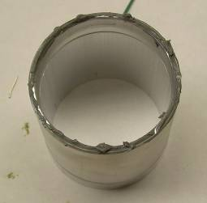
- Push the tube onto the base plate with connectors in between the locating pins. DON’T try to remove the excess until later. It smears!
- Now put adhesive on the socket (Don’t get it in the holes for the PMT pins) with the syringe (minus needle). We want a good bond at the thin edge of the tube and the part of the socket that goes up into the tube. Shown here is a socket with the beginnings of the adhesive application (and no wires which would normally be in the way).
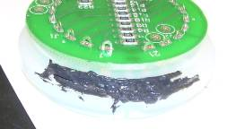
adhesive
Filed grooves

- Push the socket down on the tube while twisting slightly so the wires curl down into the tube. Plan ahead just a bit so the “missing” pin (locator spacer) in the socket ends up “sort of” aligned with the HV connector. You will be amazed at how hard it is to slide the socket around once it is seated. The actual 3/8” of insertion should be done with the socket in the final orientation.
- Again, don’t try to remove excess adhesive at this point.
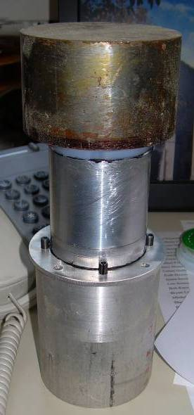
- Let dry for at least 24 hours. (The package says you can paint it in 4 hours but this is far from fully dry. Rush this and it just pulls apart in the next steps.)
- When dry, scrape any excess adhesive off the socket and tube. (The shields are a close fit.) Don’t worry about cleaning the connector plate unless you have really made a mess.
- IF you decide to do a quick test here, CAREFULLY attach a HV supply and see that the base draws 0.73mA (about) at 1500V.

CHECK THE MAGNETIC SHIELDS

At this point we are going to make pairs of shields and base assemblies. When a set works, keep them together.

- Take a rat tail file and smooth out any burs or bumps on the inside by the welds. Do both ends.
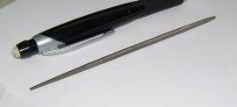
- Some tubes will be surprisingly loose. Some will be tight. Use an unassembled AL tube to find the tight ones. Some will be round and some a bit oval. You can deform the oval ones and try to make them rounder but it is very easy to overdo this and end up worse than you started.
- Take a shield and GENTLY (really GENTLY AND STRAIGHT) slide it over the assembly. If it does not slide on DON”T FORCE IT. If it gets stuck and you have to tug hard and wiggle it to get it off there is a high probability of breaking the adhesive joint. If it is too tight, try the other end of the shield or a small amount of WD40. Sometimes rotating the shield so the oval matches where the socket was a little eccentric will work. Check again for burs to be filed. (The adhesive is intentionally not that permanent to allow for future repairs. Epoxy would make this harder.) If you have a tight mu-metal shield and an assembly where the socket is slightly off center, a solution is to use a looser shield in this case and save the tight one for an assembly where everything is a big more concentric.
- Make sure you are sliding it on straight and that it is not gouging into the aluminum tube. Don’t force!
- The prototype ones ranged from just fit to a bit loose. Obviously, save the looser shields to the end to use with the assemblies needing a bit more slop in the fit.

ATTACHING THE PMT TO THE DETECTOR BAR

The bars were not marked on the outside as to which sides are the milled flat sides. This needs to be determined before mounting the PMTs. Here is what we have from ELJEN about doing this.

“Since none of the units were crated up, I looked into each the ends of the 14 finished ones still laid on our long assembly tables. I looked for differences in the images of the far end port hole as reflected down the length off of the long sides. By looking at the images very near to my end, I could fairly easily identify which sides were cast ones. When looking at the reflected images at the far end, the images have pretty much the same sharpness. However, at the end near my eye, there is a distinct difference in sharpness. The cast faces always give the crisper images. This took me less 15 minutes to do.”

In my case, the Eljen label was on the (sharp) cast side(not blurry milled side) for the first bar checked. IF YOU FORGET TO DO THIS THERE IS NO EASY WAY TO DO IT LATER! Label one flange with the words “sharp” and “blurred.”

One must have a way of positioning the PMT assembly other than trying to hold everything in place while attaching nuts and such. It will be necessary to gently roll the bar over at various points so plan ahead for space to do this.

First one wants to test fit the chosen mu-metal shield over the appropriate o-ring placed on the circular end of the bar. If the shield is one of the smaller ones then a smaller o-ring should be used. Some times one REALLY need to stretch and force the o-ring on. This stretching reduces the o-ring cross section to provide a “custom” fit. You will need a selection of o-rings from McMaster-Carr for this (every other size is probably fine – start with the 224 and get the even-numbered sizes.) They are $7-10 per pack. They are soft material for easier stretch. These are two day delivery. It may be possible for the early birds to share the left-overs but this is also only $40.
1 Pack 2418T18 Soft Buna-N O-Ring AS568A Dash Number 225, Packs of 15
1 Pack 2418T179 Soft Buna-N O-Ring AS568A Dash Number 224, Packs of 15
1 Pack 2418T178 Soft Buna-N O-Ring AS568A Dash Number 223, Packs of 20
1 Pack 2418T177 Soft Buna-N O-Ring AS568A Dash Number 222, Packs of 20
1 Pack 2418T176 Soft Buna-N O-Ring AS568A Dash Number 221, Packs of 25
1 Pack 2418T175 Soft Buna-N O-Ring AS568A Dash Number 220, Packs of 25
1 Pack 2418T174 Soft Buna-N O-Ring AS568A Dash Number 219, Packs of 25
1 Pack 2418T173 Soft Buna-N O-Ring AS568A Dash Number 218, Packs of 25
As well as adjusting the fit of the shield over the o-ring, the shield support height is adjusted at this point. Having the support block (which must fit between the rods later) on a stack of paper is an easy way to do this. Simply add or remove sheets until the shield can be pushed into place over the o-ring easily. The end of the shield does not always exactly abut the bar flange perfectly. Don’t worry here about a small gap at the top or bottom. The important part will to make sure the PMT face is parallel and centered with the light guide face latter.

Added 5/16/2010

After discussion, the group decided to modify this step to avoid adhesive on the acrylic based on Warren’s insights. This would be the point at which you would put one turn of Teflon tape around the acrylic where the o-ring sits. This will likely make is easier to seat the o-ring right up against the flange and it will make things easier if there is a future repair. The Teflon can “ooch onto the flange a bit but not so much that it will stick out from under the magnetic shield. In this case you could end up with a light leak under the tape and the adhesive might not form a good light seal. I would not undo completed bars for this change.

Remove the plastic covering from the end of the bar.

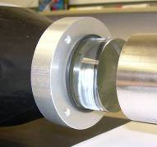.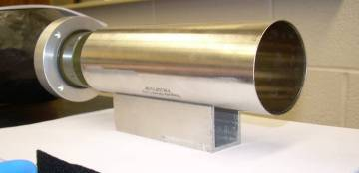

Next is to prepare the phototube. Two areas of felt are needed to center the PMT in the shield. With the felt I purchased, two turns of felt was too much. 1.5 turns was correct but then the tube was not centered in the shield. Ultimately, three pieces were taped on at equally spaced intervals and then one full turn of felt was wrapped over them. Note that the black tape is placed over the edge of the felt so that the shield slides over the felt more easily. Cut the tape with scissors rather than stretching to breaking. Remember that black tape stretched during application will creep over time. You want the tape pulled tight but not so stretched that it goes bad later.
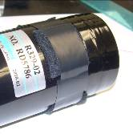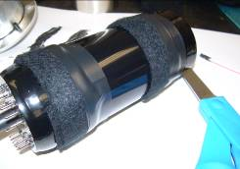
Put a voltage-divider circuit with tube assembly on the tube.

This would be good time to write the PMT serial number on the mu-metal shield. (A typical number for my tubes is RD5800.) The next step will be to add the shield at which point you can’t see the serial number. This is also the point at which it is easy to wreck the glue joint between the socket and Al tube.

Find the little hole left from manufacturing and orient the shield so that hole ends up by the divider assembly. GENTLY, slide a shield over the PMT and base. This can sometimes require a little force but once you start just try to keep going. Note, the shield should be pushed on until the end of the PMT extends past the end of the shield. Put the assembly on your stand and recheck the height. A small height (paper stack) adjustment may needed so that the PMT is centered on the stub.

Now the rods are added. Insert them through the base plate of the divider. Add a nut to the end that will go into the flange. Add a lock washer so that the washer will be between the flange and nut. Screw the rod into the flange.
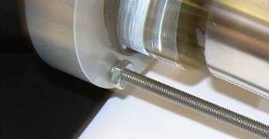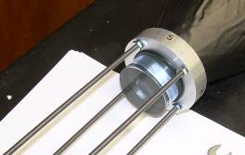
You should be able to do this by hand. Thread them into the flange to the point that when the PMT is against the end of the bar. The rods project through the base as shown. The last step of this part is to tighten the nut against the bar flange. DO NOT JAM THE WRENCH INTO THE LIGHT GUIDE while tightening. You may need to hold the rod if it wants to spin while tightening. The o-ring will be in the way at this point but also serves to protect the guide.
n

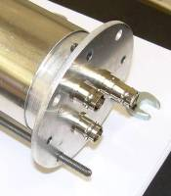

As we move forward, this is the point where you should check the orientation of the connectors. When the bar is oriented so that the milled sides are up and down, you should have the A and D connectors and A/D stamped letters at the top and upright. (On the first bar assembled, the label was on a cast side. In addition to having the A/D connectors aligned with a milled side, we also arranged it so that when the A/D stampings were upright, the label was also upright. Again, in my case, the Eljen label was on the (sharp) cast side(not blurry milled side) for the first bar checked)

Pull the assembly back (but not off the rods). Use a craft stick or coffee stirrer to place optical coupling grease on the PMT. The second picture shows too much grease. When assembled a SMALL amount of grease should ooze out but not lots.

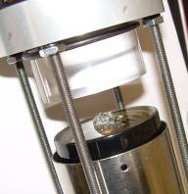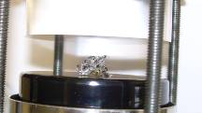

Push the assembly forward. Push and slightly twist the assembly so that the coupling compound spreads from the center out to the edge. DO NOT ROCK. Do not make bubbles. You will be able to look into the joint and see it turn from “silver” (reflected light from the paper) to “gold” (the color of the front of the PMT). Bubbles will show as small or large silver spots. A few small flecks are okay. Large areas of silver are bad. The following picture shows the view of the joint with your eye over the bar looking toward the PMT. Note it is gold with no appreciable silver/white spots.

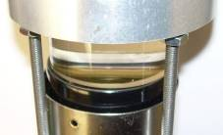

Now a spring, lock washer and nut are threaded onto the rods. HAND TIGHTEN these a little bit at a time going from rod to rod. Do not use a wrench. They are not tightened all the way down. The picture shows the location when the tension is reasonable. The springs should not be fully compressed; the assembly should feel solid; the joint should be free of silver.

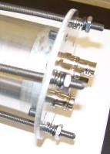

Surprisingly the DAP adhesive can be easily pushed through a large bore syringe with an exit opening of ~1/32”. This works well for the most of the space but it is important to get the adhesive in the space between the nuts and the o-ring. Gaps here could result in light leaks. To reach into this area more easily, we also got 16 gauge 1.5” needles for the syringe (not shown) and cut off the tip square. These are sharp; BE CAREFUL. Cutting off the pointy part makes them safer and easier to use.

“I walked over to our chem dept and got a syringe and needle that work very well with the adhesive. Without the needle on, it is perfect for the assembly of the base plate and socket to the tube. With the sharpest part of the needle clipped off it is good for the shield. If you don't have a friendly chem stock room you can order the syringe from JRS medical part number BND309653 $28.30 for a box of 40. (If you plug jam the tip in to syrofoam or eraser it seems to not dry out too quickly).
The needles are from sigma-aldrich (although I just ordered 100 and can share some) 305198 from Becton Dickinsen. It is a 16 gauge 1.5" long.”

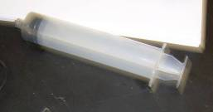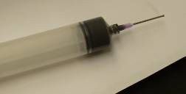

Adhesive is spread all the way around the outside of the o-ring. The challenge is to get adhesive between the o-ring and the nuts on the flange. The needle mentioned above should easily do the trick. Use the needle to get adhesive in the area between the nuts and o-ring. Use a syringe with no needle for the majority of the space (easier to get a good amount in place.) Rotate the bar as needed to do a good job. Avoid getting adhesive on the acrylic but a small amount is not an issue either. It is hard but important to insure things are light-tight. Be sure the space between the nuts and o-ring is filled and more is probably better than less in this step. (Note, the two spots by the nuts in this picture were not done very well since this picture was taken pre-needle. Subsequent ones had more even coverage.)
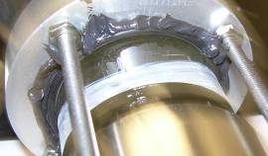

Push the shield over the o-ring into the adhesive while doing a slight twist. (Hold the base end while doing this. Don’t try to clean or smooth (yet, see below).
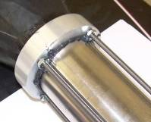

Tape is added around the other end of the shield. This was done with two pieces because the tape has to go under the rods. You may wish to wait to add the bottom tape until the adhesive has a chance to dry. With care and patience this can be done with one longer piece but two pieces are also fine.

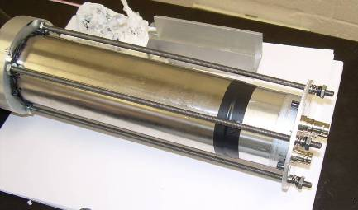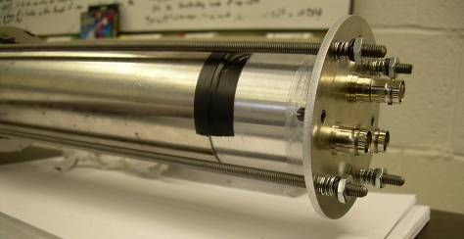

Now take a coffee stirrer or other small rounded piece of plastic and smooth the adhesive that oozed out back into the corner where the shield meets the flange. The goal is light tight more than pretty here. If you think there are spots lacking a good seal (especially pay attention to the nuts) add more adhesive with the syringe. Use the needle if needed to get a good seal in the area of the nuts and washers.

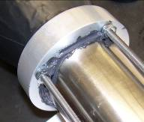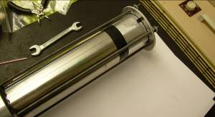

Be sure to cover the production hole in the shield with a small piece of tape.

Once things are dry (24 hours) smudges can be cleaned up, the bar can be turned, and the taping at the connector end can be finished.

What to do if assembly goes bad and you need to take one apart?

Well, it is bound to happen, you need to repair an end for some reason Bob and I suggest this....
1) remove as much of the adhesive from the flange/shield joint as you can.
2) remove the tape from the connector end of the shield.
3) support the assembly while sliding the shield back onto the divider base (off the bar) until the PMT/bar joint is exposed. (Working around the joint with a screwdriver to "pry" it loose a little at a time is probably better that lots of twisting.) This is prying the shield from the flange. DO NOT EVER PRY THE PMT LOOSE LEST YOU DAMAGE THE GLASS OR PLASTIC.
4) replace the support under the shield.
5) remove the rods
6) GENTLY decouple the pmt from bar. Sliding sideways is better than trying to torque, twist, or pull
7) Now, DON'T PULL the pmt out of the shield.
8) Find a strong cardboard mailing tube (not too small in diameter), pad the end well (you don't want to scratch or push only in the middle of the tube), and GENTLY push the pmt/socket/Al tube out of the mu metal shield. (If you try to pull you will just end up doing this anyway but now the joints and wires will be broken and it is possible that traces will be damages on the boards. DO THIS WITH TWO PEOPLE! One to hold the cardboard and slide the shield and one to make sure the PMT is NOT dropped when the shield comes off. In other words, slide the shield down over the cardboard tube as if it were the round end of a bar.
NOTE: if you feel you can not push the PMT out with out breaking, it is better to break the divider end and push the pmt out by pushing on the socket.

NEXT UP – TESTING

There are several phases of testing.

1) Light tight?

You should wait a few hours after the bar assembly is complete before performing the light test in order to allow the photocathode to settle after being exposed to room light. Place an oscilloscope (50 ohm termination and DC input) on the anode and put about -1200V (that’s negative) on the tube. Start with minimal lighting in the room and observe the noise level. Turn on the lights and see if the noise increases or the base line shifts away from ground. If the noise does increase, there is a light leak that needs to be repaired. One suggestion to localize the spot is to turn out the room lights and use a small LED flashlight to localize the problem area. The signals from cosmic rays should have a 3-5 ns rise time and be narrow.

The following paragraphs are a better summary of initial testing from OWU

OWU Light-Tight Test Observations and Procedure
While performing the light-tight tests of our bars, we discovered that the baseline level of the PMT anode outputs did not remain at ground as we increased the tube bias potential beyond about –1200 V (i.e. made them more negative). Although Hope College was reporting no visible DC offset with bias voltages as large as –2000 V, such a bias typically produced a DC offset of tens to hundreds of mV below ground during our tests.
With Paul’s help, we appear to have discovered the root of this problem, and have developed an updated procedure for the light-tight test. First, it is very important to use 50-Ω termination and DC coupling for the anode signal into the oscilloscope. (Some scopes offer a 50-Ω input impedance as a selectable option. If not, then a 50-Ω terminator will need to be teed with the anode signal at the scope input.) If a high input impedance (typically 1 MΩ) is used instead, then the signals become much longer in time and never fully return to ground at high counting rates when the tube gain becomes especially high at higher bias voltages, causing the baseline level to sag. Such was the case when we were initially using a 1 MΩ input impedance on our scope, and thus terminating the anode signals through a high-impedance load.

When beginning the light-leak test, we recommend setting the scope to a vertical scale of 5 mV or so to keep a close eye on the baseline level of the anode signal. As the bias voltage is increased (more negative), there should be no visible baseline shift on this scale. If a shift occurs as the voltage is increased, then there is likely a light leak which needs to be repaired before continuing (otherwise the tube photocathode could be damaged by currents that are too large). If no baseline shift was observed, then we continued to increase the bias voltage until we saw (approximately) a couple of signals per second appearing on the scope with a trigger level of –1 V (scope set for normal triggering, a horizontal sweep rate of about 200 ns per division, and a vertical scale of about 200 mV/division). This accounts for the varying intrinsic gains of each tube and provides a test at approximately the same gain for each tube. Once that bias voltage was reached, we returned the scope to a 5 mV/division scale and looked carefully at the signal baseline. If no shift was visible, we considered the bar light tight. The images below show scope screen captures of the anode signal for a light tight tube assembly using a 200 mV/division scale (top) and a 5 mV/division scale (bottom). Note that some “fuzz” on the baseline is normal, as it probably arises from the thermal emission of electrons from the surface of the photocathode.

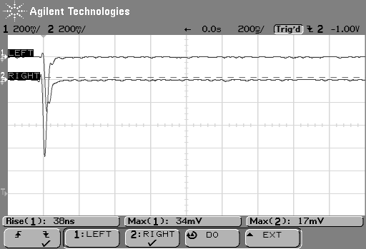

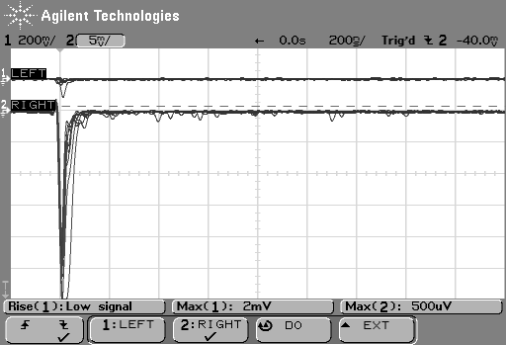

2) Gain match.

You’ll need a pulse amplifier and a multi-channel analyzing system, whether it consists of a single self-contained MCA unit or a more involved combination of timing and signal digitizing electronics. Pick a tube with medium gain according to the spec sheet and set it to about -1500V. Depending on the input requirements for your amplifier, direct either the anode (negative) or dynode (positive) signal cable into the amplifier. Adjust the gain (and possibly the pulse shaping) on the amplifier in order to get a good signal. Cosmic muons deposit approximately 2 MeV per cm of scintillator, so you should see signals of around 20 MeV. Record an energy spectrum of cosmic muons – below is an example of such a spectrum, acquired using VME-based electronics similar to the MoNA setup – a constant fraction discriminator for timing, and an ADC for energy signal digitization. The muon energy deposition peak in this spectrum appears at channel 1800, and the sloping background underlying it is from muon-scattered electrons from the ceiling and surrounding matter.
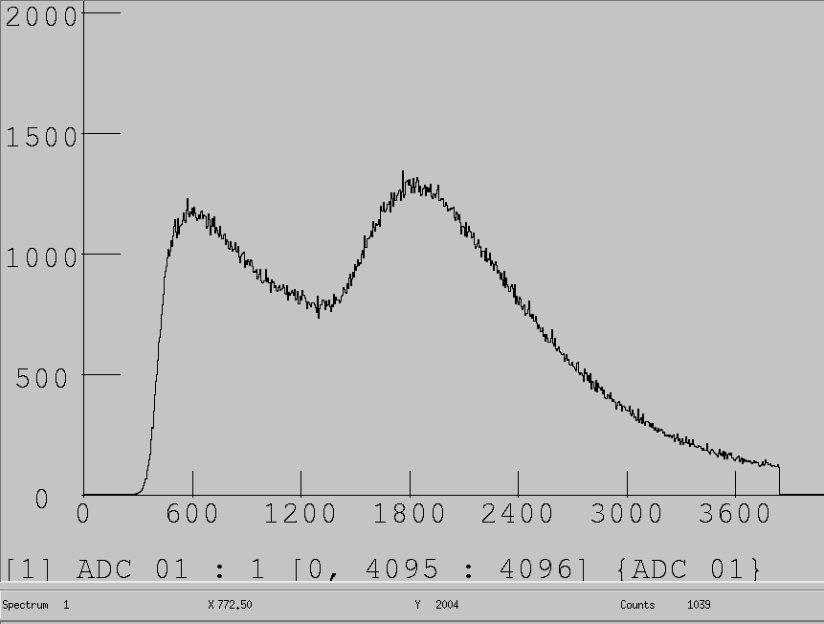

In turn, look at the other tubes and adjust the HV to get the peak in the same place. IF YOU FIND YOU NEED EXCESSIVE VOLTAGE, LIKELY YOU HAVE A BAD LIGHT JOINT! Do not exceed -2200V. Record the final voltages and make a plot of voltage versus spec sheet gain with one point for each tube. What is shown here are results from CMU of the correlation between the voltage to gain match and column two of the Hamamatsu spec sheet. Of course this will vary from school to school because of different overall electronic gains, adcs, and reference channel but should be consistent within one institution.

Some pictures from CMU – more detail later about the preamp in use here. Hope has been skipping the preamp and taking the dynode directly into a shaping amp. I feel like whatever works is fine.
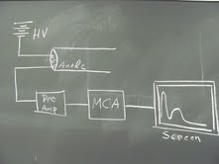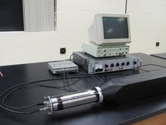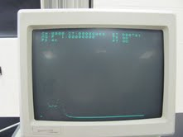

3) Measuring the light attenuation.

Using a ⁶⁰Co source placed at various points along the bar’s length, observe the Compton edge (scintillators won’t produce a gamma photo-peak). Note that you will need to increase the phototube voltage fairly significantly in order to see the much weaker gamma signals (sub-MeV vs. 20MeV) Record the channel location of the Compton edge (a convenient spot is the location of the ½ height). The figure below shows several superimposed Compton edge spectra – each corresponding to a different 60Co source location on the bar. The spectrum with its edge furthest to the right corresponds to the source being closest to the PMT, and the orange spectrum furthest to the left is room background.

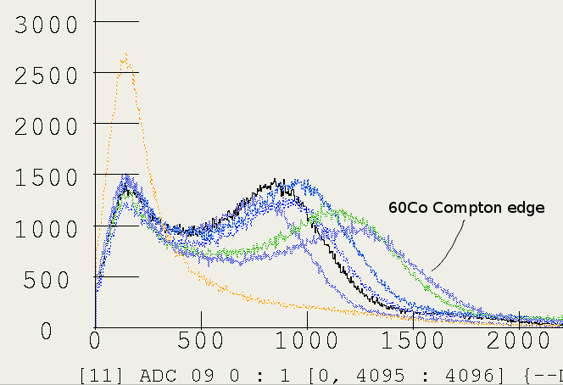
Don’t change the gain on the phototube as you vary the position of the source. Arrange the voltage on other tubes in order to place the Compton edge at the same channel for the same starting position. Measure the edge locations for 5-7 source positions starting at end of the bar closest to the PMT. We would like to see all the bars have the same attenuation properties.

Note that attenuation arises from a convolution of two origins. One origin is the bulk attenuation of the scintillator material, and the other is from the not-perfect internal reflections in the bars. When Compton edge-channel location is plotted vs. source location, the result should be an exponential curve. Note in the curve below that the two points closest to the PMT lie above the exponential that is formed by points further down the bar. This arises from the fact that very little reflection occurs for the light produced from the source being located very near the PMT, compared with points further away for which reflection plays a much larger role in attenuating the light. The attenuation length resulting from the curve which does not include these first two points is around 5.8 m.



4) Position Spectrum

This is a more involved measurement, since you will need two separate channels of CFD and a TAC unit. Feed each of the PMT anode signals to separate CFD discriminators, each of which will then be directed to the start and stop of a TAC unit. The TAC output then yields the position spectrum. Alternatively, each CFD signal can be directed to a TDC (in this case the same Caen V775 used in MoNA), and the position spectrum is formed out of the difference in the output of the two TDC channels. After some time of running the position spectrum should look like the following. The “bat ears” at ends of the bar result from a type of “pile-up” signal from muons that pass partly through the end of the scintillator and partly through the acrylic light guide, which are registered as occurring at the bar’s end.

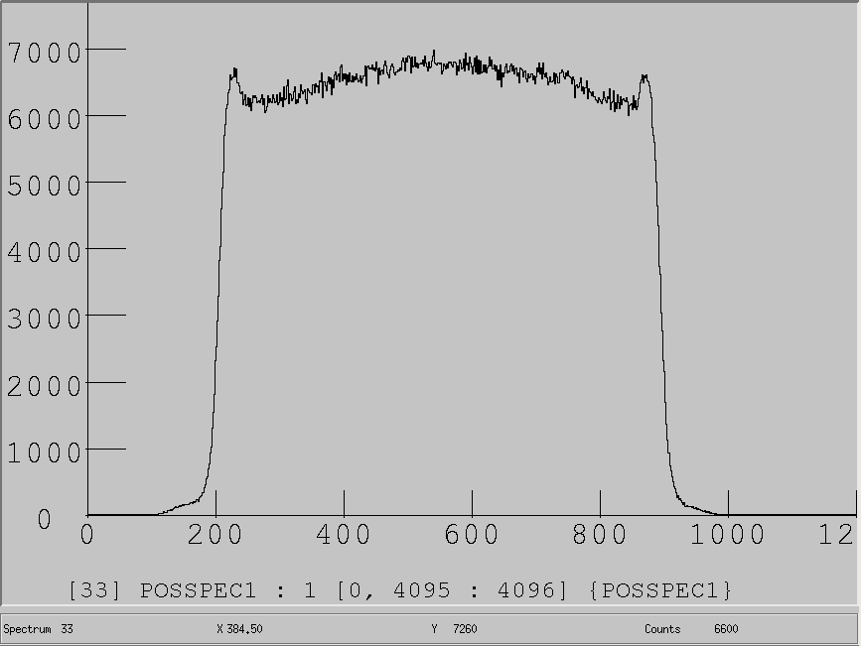

ADDITIONS on July 22, 2010

Here are presented some items that were found, developed, or fixed since version 12 of the guide. Included are two plots from Hope results, Notes from OWU on simplified position testing, a short description of some odd observations, and the guide on preventing light leaks.

Hope attenuation curve and voltage-sensitivity plot:

Typical light attenuation curve. The shape is approximately the same as for the older MoNA modules.

Check of PMT voltage from module gain matching versus specification sheet sensitivity. The good correlation indicates that there is good optical coupling.

The OWU-WESTMONT approach to position measurements

Alternatively, one can use the two PMT anode outputs for each bar directly as START and STOP inputs to a TAC (without the need for two CFD channels or other means of signal discrimination), assuming that the TAC accepts negative input signals. (One anode output serves as the START input, the other as the STOP.) We simply used a cable for the STOP input that was about 5 m longer than the cable used for the START input of the TAC. This introduces a delay in the STOP input that is about 25 ns relative to the START input, which is consistent with bars that are about 2 m long with an index of refraction of about 1.5. The spectrum below shows the resulting TAC output generated from our setup after collecting cosmic-ray muon and other room background events for several hours, using a TAC range of 50 ns. It is very similar to the example spectrum provided by Westmont, which used a more sophisticated electronics setup.

Two observations from working with the modules:

1 Jerry reported seeing divider resistances less than 2.2 Meg. Last week we saw that too but add the following additional observation. We observe this phenomenon when we run a bar, turn off the high voltage and measure right away. If we wait 15 minutes (with a HV cable connected or not) the resistance is correct. I am guessing this is some sort of dark current or capacitor discharge effect. Anybody else want to weigh in on this with observations? Could somebody do a quick test on one of the CMU bars (where we can also read the current draw when turned on)? Please?
2 Just another observation. If you look at the dynode with the anode OPEN, it appears that the anode charges up and then the dynode switches to a negative signal instead of a positive one. Always keep the anode connected either through a device (discriminator, amplifier, etc) or use a 50 ohm terminator. (This was very confusing at one point where we had a negative anode and negative dynode - one from one end and the other from the other end.) I suggest that you do not apply HV unless the anode is connected. The super cautious may want to move the anode connection only when the HV is off.

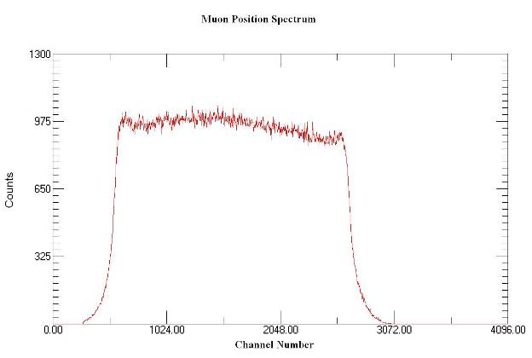

PREVENTING FUTURE LIGHT LEAKS AT THE BAR CORNERS

Prevention of the Development of Light Leaks

We have noticed a few light leaks occurring in our bars where the square part of the bar meets the light guide. In these leaks, the outer plastic coating and inner reflective coating in the bar have been split apart, revealing the actual bar. We believe that these leaks are the result of the reflective and plastic coatings being stretched tightly against the sharp edges of the bar. We have also noticed that new leaks develop in this way over time since one bar that had no light leaks a few days ago had one yesterday even though it had not been moved. This guide describes how to prevent these leaks from developing.

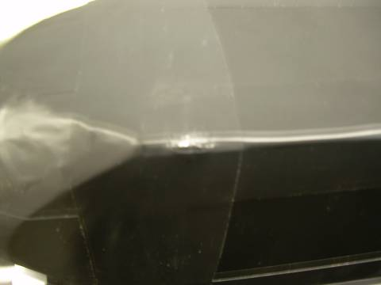

Right: A split corner on a bar

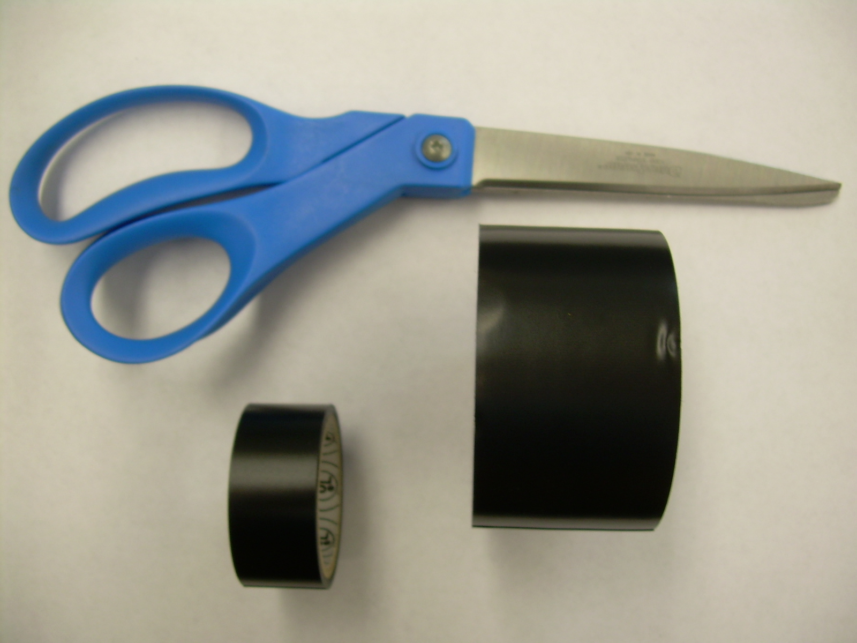

Right: Materials to be used

Materials (shown above):
1 pair of scissors
1 roll of electrical tape (about 19 mm wide, the type used to tape felt to the PMTs)
1 roll of electrical tape (about 38 mm wide, we’re using 3M Scotch 88T All Weather Telephone/Vinyl Plastic Tape)

The Process:

Basically, each of the four corners on each end of every bar will be covered with 3 pieces of the 19 mm electrical tape. Each end will then be wrapped in one layer of the 38 mm tape.

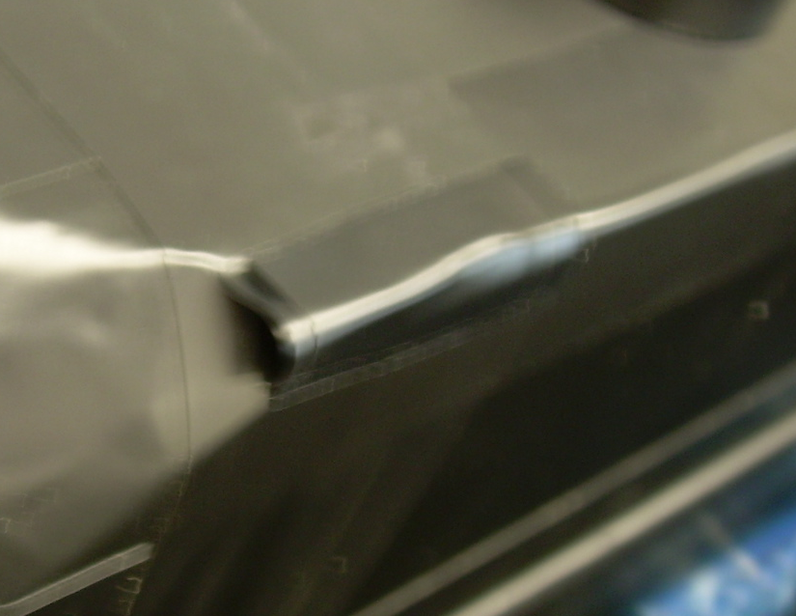
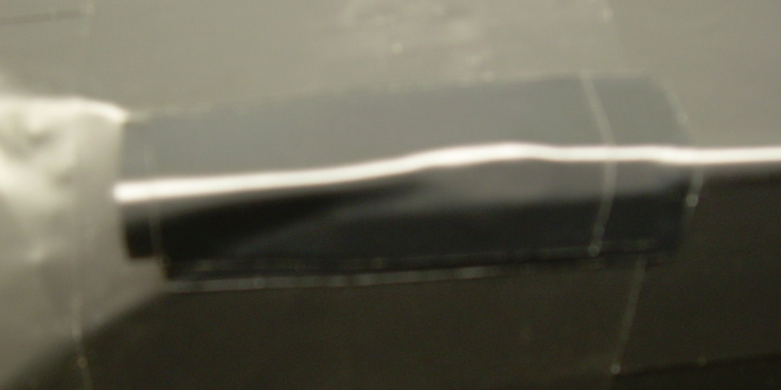
- Attach 3 pieces of 19mm electrical tape to the corner of the bar with the length going parallel to the bar. Each piece of the tape should be about 4 cm long. Half should be along the bar and half along the light guide. The part over the light guide should not yet be stuck on except along the edges (shown below).

- Using your scissors, make a slit in the tape that is sticking up over the light guide. Make the slit long enough that it reaches nearly to the start of the actual bar. This should create two small flaps of tape over the light guide, still not stuck to the light guide. BE CAREFUL NOT TO DAMAGE THE WRAPPING THAT IS ALREADY ON THE BAR!
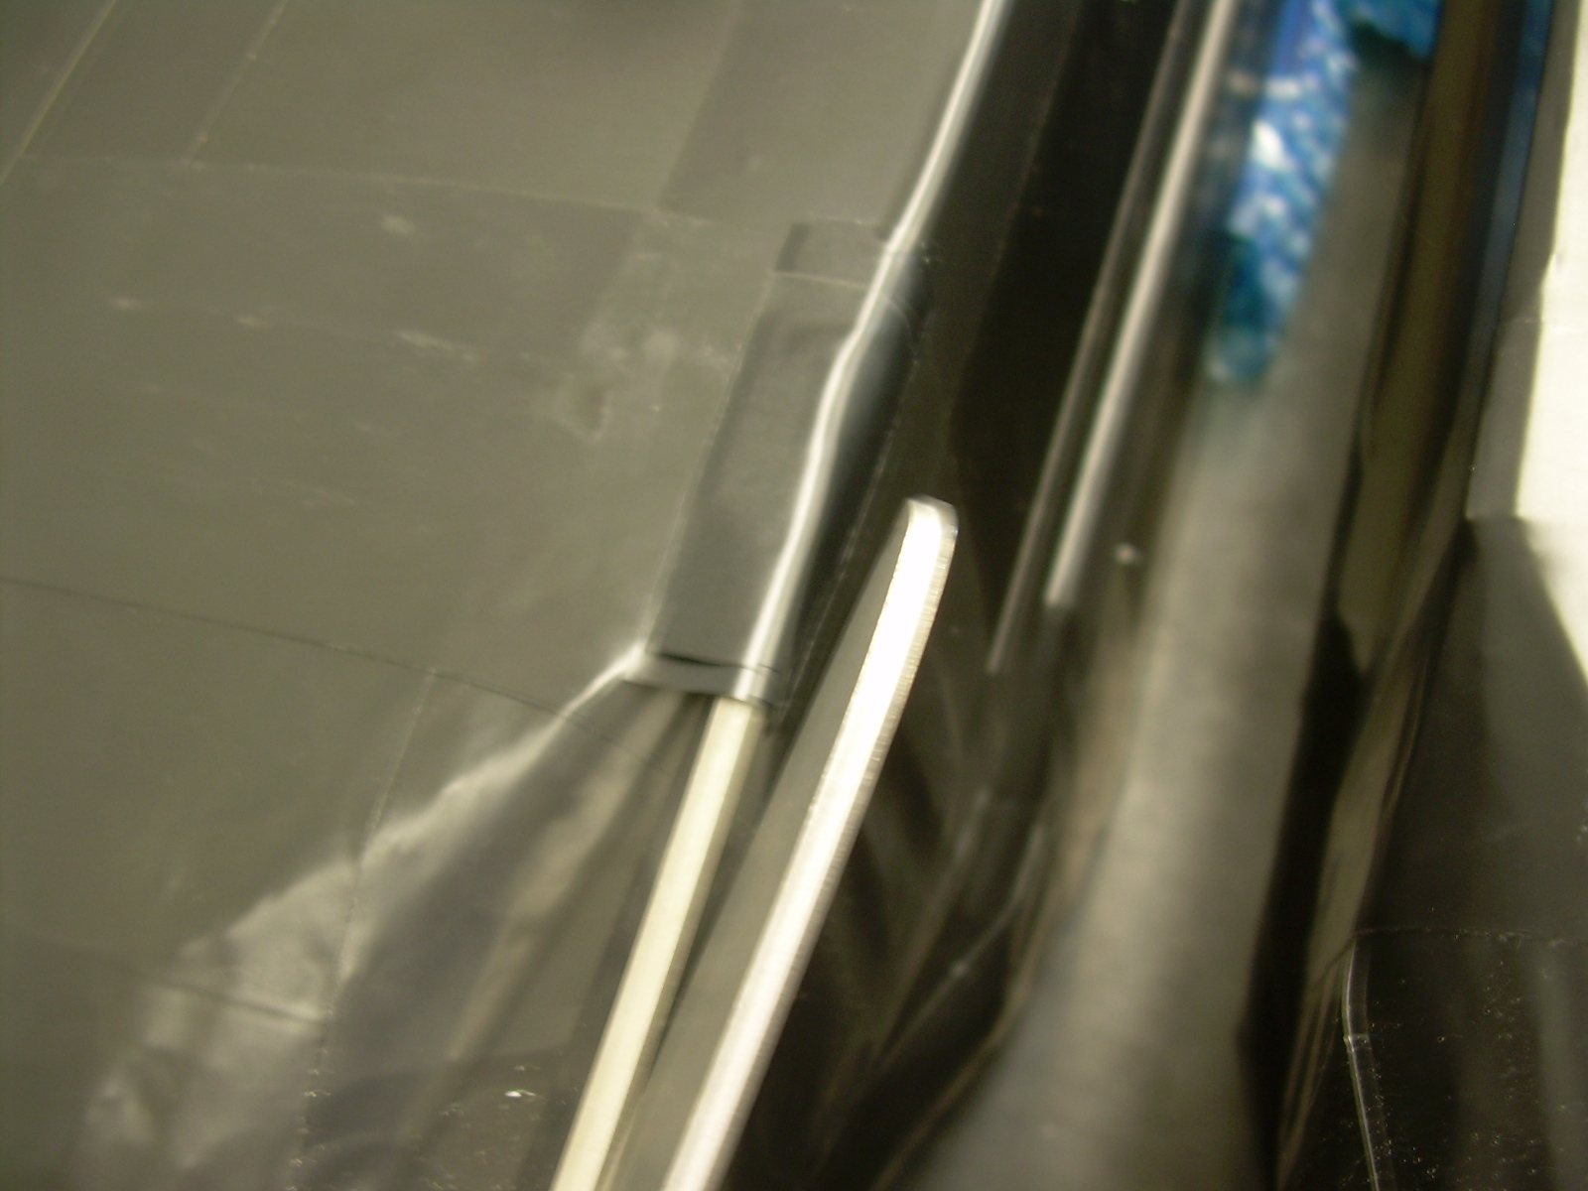

- Flatten one flap of the tape against the light guide and then the other. They should lay flat against it and not have any bits sticking up. These pieces of tape are crucial in that they provide an extra barrier between the bar and the light outside the bar.
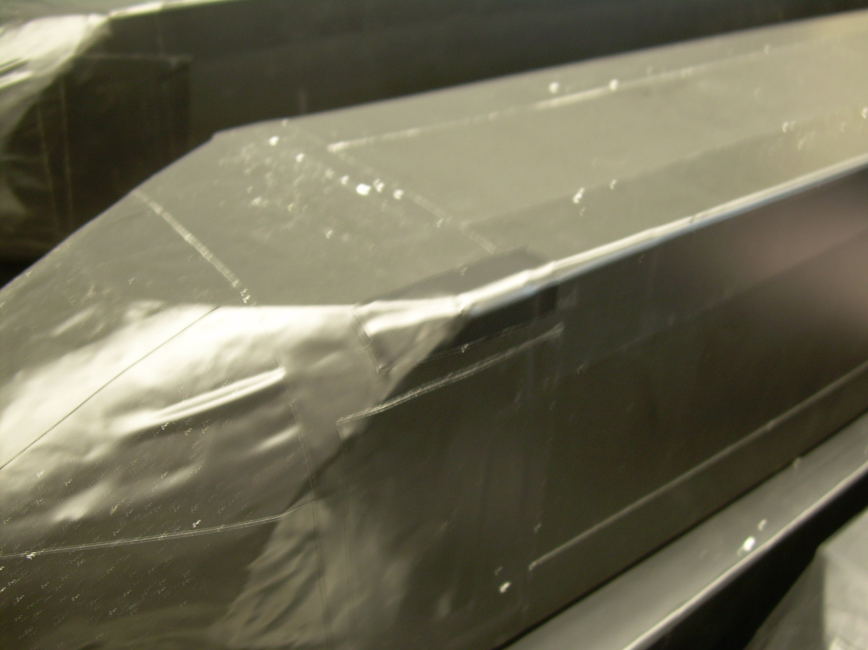

- Cut off a long piece of the 38mm wide tape (about 45 cm long so that it can go around the entire bar). Wrap this piece around where the light guide meets the bar so that one half of it is on the bar and one half over the light guide. The picture shows a piece that is longer than necessary. It should wrap all the way around the bar, providing one more layer of support and covering the smaller pieces that were just attached. When this is done, repeat steps 2 and 3 for the 38mm tape (slits in the tape over the light guide).
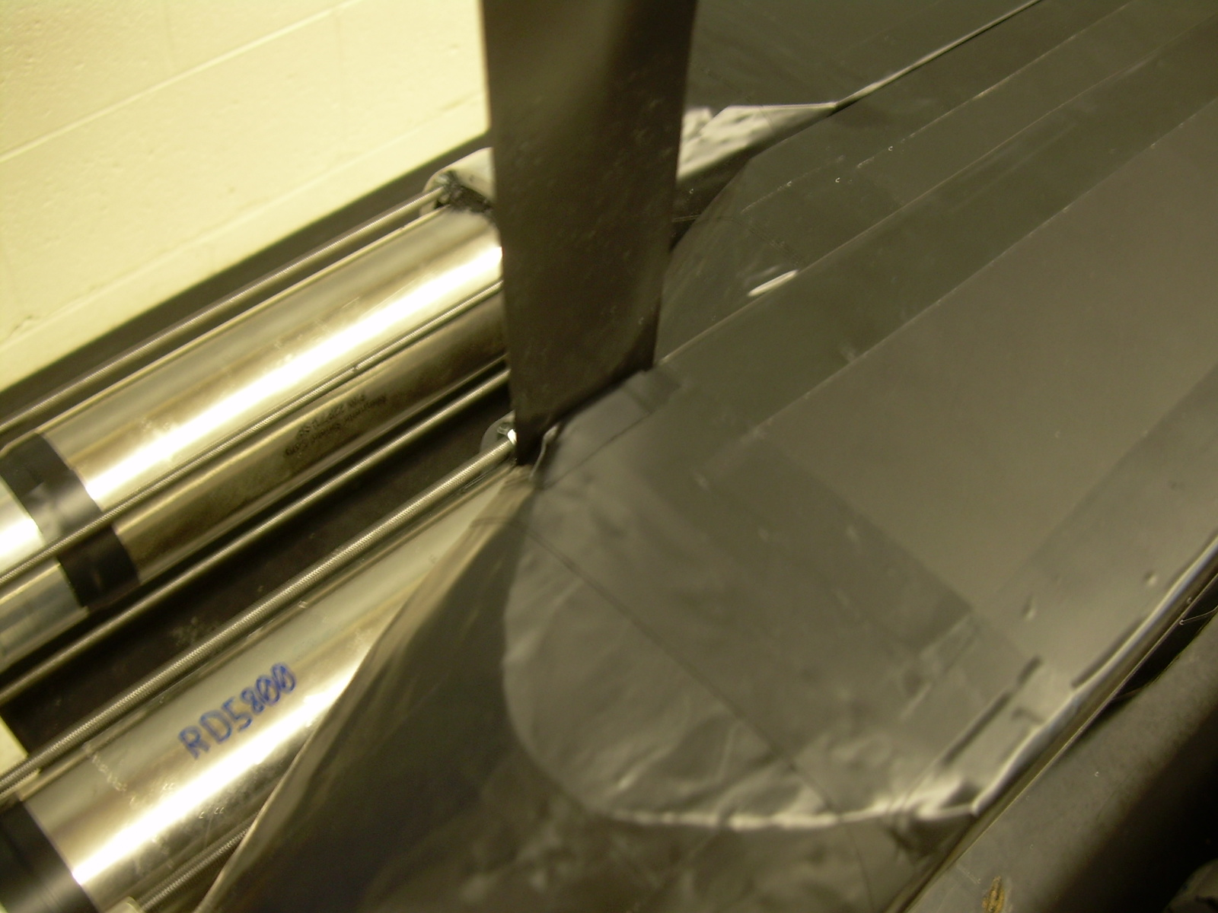

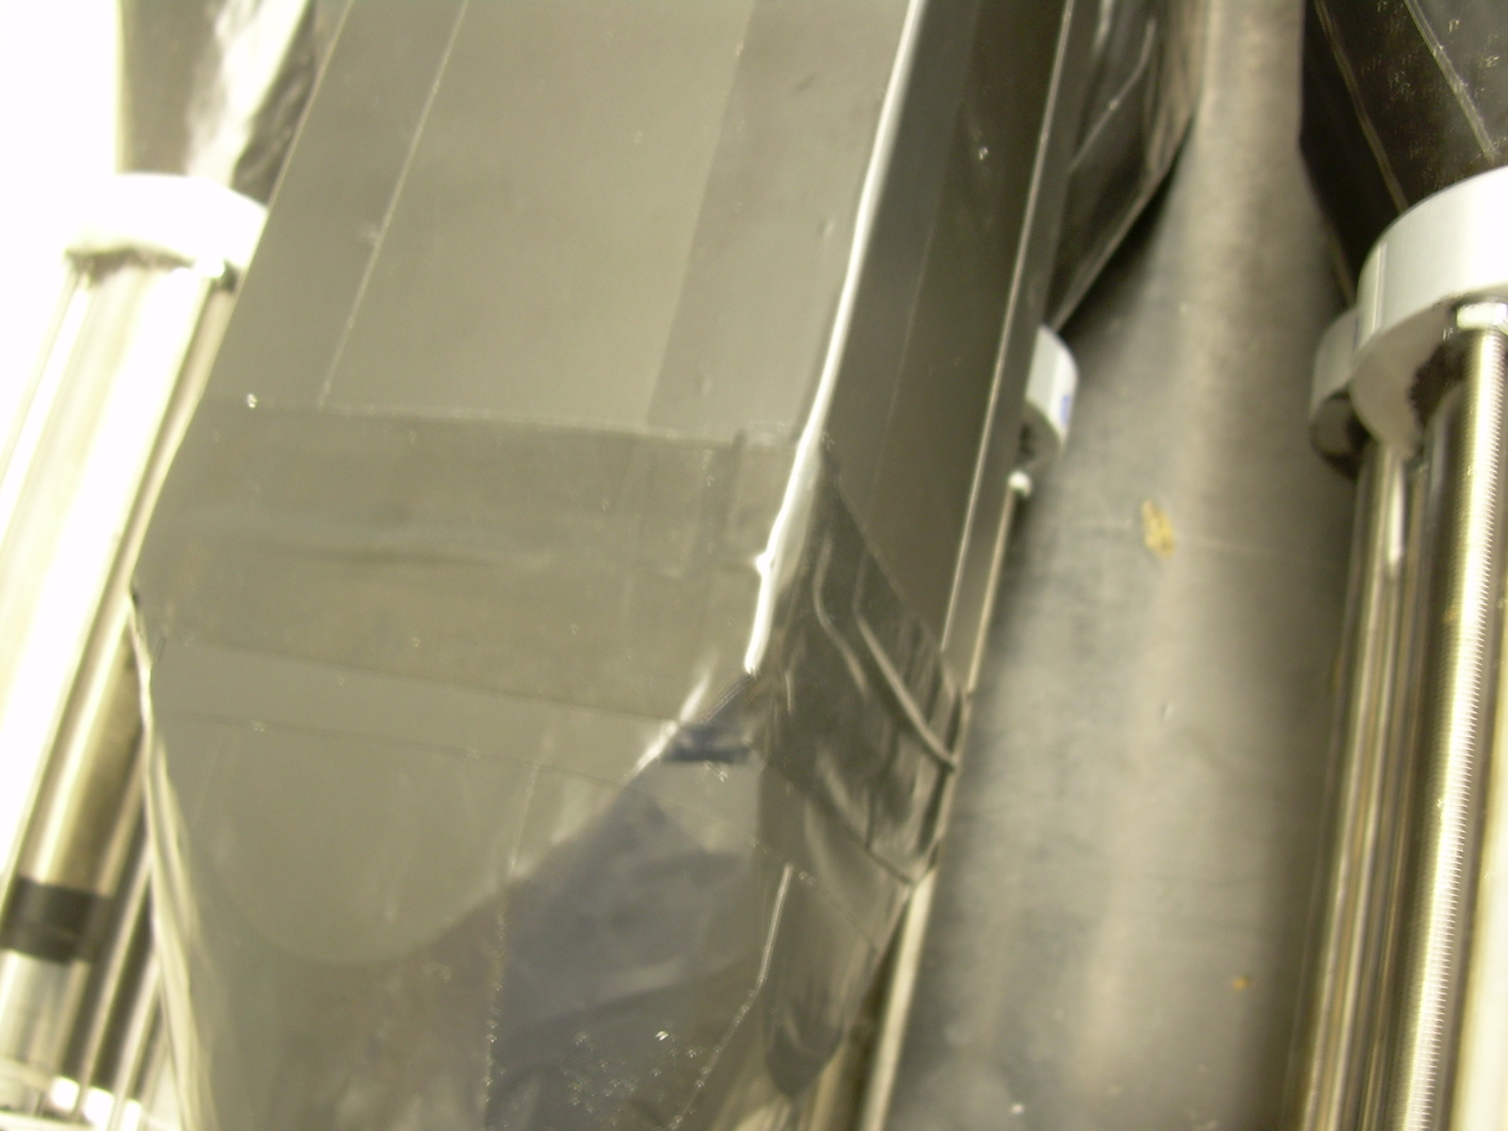
The finished product -->

